Maintenance Phase Proposal for the Backyard Adventures Reservation System

Draven Chen
Southern New Hampshire University

Maintenance Phase Proposal for the Backyard Adventures Reservation System
This proposal builds on two earlier reports prepared for Backyard Adventures (BA), a tour and water sports rental company in Jacksonville, Florida owned by Shawn and Harry Weaver. The first report recommended replacing BA's single-user Microsoft Access reservation database, currently managed by administrative employee Melissa Smith, with a configured, cloud-based reservation and business management platform. The second report recommended an Agile approach for configuring and rolling out that platform, given BA's small, closely coordinated user base and its largely known but still-evolving requirements. This report addresses a phase of the systems development life cycle (SDLC) that is often under-resourced once a project team moves on: maintenance. It outlines the types of maintenance BA's new system will require, the activities and costs involved, a knowledge-retention policy, and two forward-looking practices, software re-engineering and component reusability, that will help the system stay useful as BA's needs continue to change.
Types of Maintenance
Software maintenance is generally organized into four categories, each of which will apply to BA's reservation system at different points after go-live.
Corrective maintenance addresses defects discovered after the system is in real use, such as a scheduling-conflict rule that fails to flag an overlapping multi-day tour booking, or a reporting error that miscounts rentals from a particular referral source. Because these defects surface only under real conditions that testing did not fully anticipate, Melissa needs a simple way to report a problem as soon as she notices it, rather than waiting for a scheduled review.
Adaptive maintenance responds to changes in BA's operating environment rather than defects in the system itself. Examples include updating the system to work with a new payment processor, adjusting to a change in the marina's operating hours, or complying with a new data-privacy requirement for stored customer information. Because BA is a small business without in-house developers, adaptive changes will typically originate from the platform vendor's updates, but BA still needs a process for reviewing and testing those updates before they affect live reservations.
Perfective maintenance improves the system's usability or performance based on feedback rather than fixing something broken. For BA, this includes streamlining the reservation-entry form once Melissa has used it through a full high season, or adjusting the reporting dashboard so Shawn and Harry can filter results the way they actually think about their business. Perfective maintenance is where the parallel-run and post-implementation review already proposed in the earlier reports pay off, since they give BA a structured point at which to collect this kind of feedback.
Preventive maintenance is proactive work performed to reduce the likelihood of future problems rather than react to a defect or a request. For BA's cloud-hosted system, this includes applying vendor security patches, monitoring system performance during peak booking periods, and periodically verifying that customer data and backups remain accurate and complete.
Cost of Maintenance
Maintenance is consistently the most expensive phase of a system's life cycle. Industry estimates suggest maintenance can account for the majority of a system's total lifecycle cost and effort (TMS Outsource, 2026), and Haleem et al. (2025) similarly note that maintenance requires significant, ongoing financial outlay covering bug fixes, performance tuning, new features, and regulatory compliance, and that inaccurate cost estimates can lead to budget overruns and understaffed support. For a small operation like BA, this means the subscription or licensing fee for the new reservation platform should not be treated as the full cost of the system. BA should budget separately for a modest, ongoing allowance covering periodic troubleshooting, occasional configuration changes as the business evolves, and Shawn's time spent coordinating with the platform vendor. Because BA's system is a configured, off-the-shelf platform rather than a fully custom build, its maintenance costs should be lower and more predictable than a custom system's, but they are not zero, and planning for them now avoids the common pattern Haleem et al. (2025) describe, where organizations underestimate maintenance costs and are caught off guard once the system is in daily use.
Maintenance Activities
Regardless of which type of maintenance is involved, a consistent set of activities keeps changes controlled rather than ad hoc. For BA, this process should include the following steps.
Identification and reporting begins the process: Melissa, Shawn, or Harry notices a problem or improvement opportunity and records it, whether through a simple shared log, an email to the vendor, or a support ticket, rather than mentioning it informally and letting it be forgotten.
Analysis follows, in which the request is reviewed to determine its type (corrective, adaptive, perfective, or preventive), its urgency, and roughly what it will take to address, such as whether it requires a vendor-side fix, a configuration change BA can make itself, or a larger reconfiguration.
Design and implementation come next: for a configuration change within BA's control, such as adjusting a report or a form field, Shawn or a designated support contact makes the change directly. For anything requiring a code-level fix, the platform vendor implements it, since BA does not maintain in-house developers.
Testing verifies the change before it reaches live reservation data, using the same kind of scenario-based approach recommended in the earlier report, entering test bookings, checking for conflicts, and confirming reports still calculate correctly.
Delivery and closure puts the verified change into production and records what was changed and why, closing the loop back to the original report so BA has a running history of what has been modified over time.
Knowledge-Retention Policy
Maintenance is fundamentally a knowledge-intensive activity: understanding why a system behaves a certain way, what past changes were made and why, and how the pieces fit together is often harder to recover than the original code or configuration itself once the people who built it have moved on (Anquetil et al., 2007). This risk is especially real for BA, since the business has no in-house technical staff and depends on Melissa's day-to-day familiarity with the system and on whatever contractor or vendor configures it.
BA should adopt a simple, written knowledge-retention policy with three parts. First, every configuration change, no matter how small, should be logged in a shared change record noting what was changed, why, and by whom, so the reasoning behind a setting is not lost even if the person who made it is unavailable later. Second, BA should maintain a short internal reference document, similar to the quick-reference guide proposed for staff training in the earlier implementation plan, that captures not just how to use the system but why key settings are configured the way they are, such as why a particular conflict-check rule exists. Third, BA should ensure cross-training between Shawn and Melissa so that operational knowledge of the system does not rest with only one person; if either Melissa or the Weavers eventually work with a new contractor or vendor, this documentation and cross-training reduce the business's dependence on any single individual's memory. Because BA is small, a shared document and a habit of writing things down as they happen, rather than a heavier formal knowledge-management system, is proportional to its size and will meaningfully reduce the risk that valuable context about the system is lost over time.
Forward-Looking Activities
Software Re-Engineering
Software re-engineering is the process of examining and modifying an existing system to improve its structure, maintainability, or functionality without necessarily rebuilding it from scratch. Re-engineering typically combines reverse engineering, understanding how the current system works, with forward engineering, applying that understanding to build an improved version. For BA, re-engineering will become relevant a few years after go-live, once the initial reservation platform configuration has accumulated small adjustments and BA's needs have grown, for example if BA later wants to integrate its separate accounting software with the reservation system rather than keeping them apart. At that point, rather than replacing the entire platform, BA and its vendor can re-engineer specific parts of the configuration, such as the data model connecting customer records to bookings, to support the new integration while preserving the parts of the system that already work well. This approach is generally more cost-effective than a full system replacement and preserves the institutional knowledge already built into the existing configuration.
Component Reusability
Component reusability involves identifying discrete, well-defined pieces of a system, such as a specific scheduling-conflict rule, a report template, or a data-validation check, that can be reused elsewhere rather than rebuilt each time a similar need arises. For BA, this is directly relevant to the maintenance process described above: once a perfective change to the reservation-entry form has been designed, tested, and delivered, that same component (for example, the customer-lookup logic) can be reused if BA later adds a related feature, such as a rental add-on or a loyalty tracking field, instead of building similar logic again from scratch. The figure below illustrates the process BA should follow when identifying and reusing a component during future maintenance work.
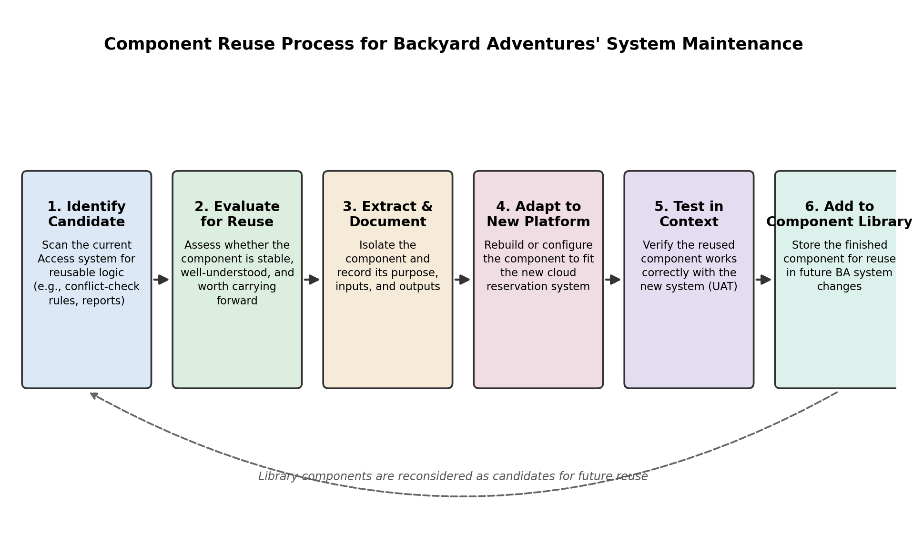
Figure 1. Component reuse process for Backyard Adventures' system maintenance.
Following a defined reuse process like this one keeps BA from treating every future change as a brand-new build, reduces the amount of new configuration or code that has to be tested from scratch, and, combined with the knowledge-retention policy described above, ensures that a reusable component's purpose and history remain documented rather than rediscovered each time it comes up again.
Conclusion
The maintenance phase is where a systems project either continues to deliver value or slowly falls out of alignment with the business it was built to support. For Backyard Adventures, a clear plan covering corrective, adaptive, perfective, and preventive maintenance; a realistic view of ongoing costs; a consistent set of maintenance activities from identification through delivery; a written knowledge-retention policy; and forward-looking practices such as re-engineering and component reuse will help ensure that the new reservation system proposed in the earlier reports continues to serve Shawn Weaver, Harry Weaver, and Melissa Smith well beyond its initial rollout, rather than becoming another system that quietly falls out of date once the project work is considered finished.

References
Anquetil, N., de Oliveira, K. M., de Sousa, K. D., & Batista Dias, M. G. (2007). Software maintenance seen as a knowledge management issue. Information and Software Technology, 49(5), 515–529. https://doi.org/10.1016/j.infsof.2006.07.007
Haleem, M., Islam, M., Ahmed, M. N., Farooqui, N. A., Khan, A. N., Hussain, M. R., Ahmed, J. S., Ahmed, M. M., & Khan, I. M. (2025). A critical review for software maintenance cost estimation models: A data driven approach. IEEE Access. https://doi.org/10.1109/ACCESS.2025.3618759
MobiDev. (2026, April 30). How to build effective software re-engineering strategy. https://mobidev.biz/blog/how-to-build-effective-software-reengineering-strategy
TMS Outsource. (2026, April 3). The 7 phases of SDLC explained clearly. https://tms-outsource.com/blog/posts/what-are-the-7-phases-of-sdlc/

